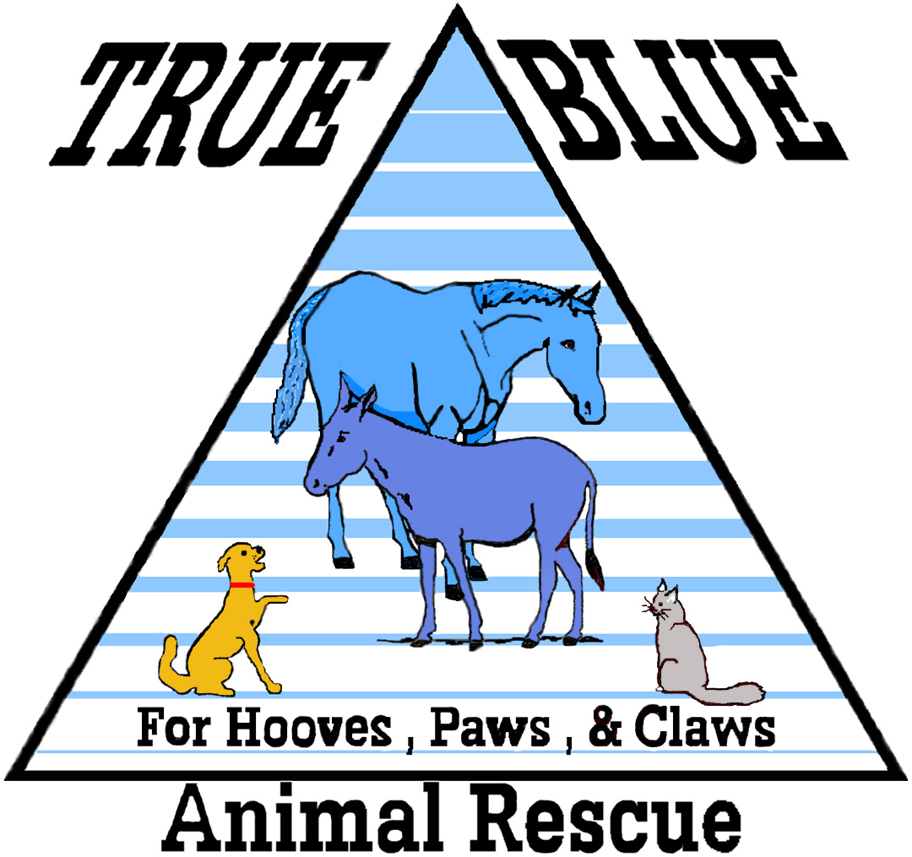 | True Blue Animal Rescue  P.O. Box 1107  Brenham, Texas 77834  Saving Animals One Life At A Time | 936-878-2349  http://www.t-bar.org/  help@t-bar.org

TBAR Officers will handle your report as quickly as possible. Upon verification, we will forward the report to the proper authorities and follow up on their findings. *Your name will remain anonymous*.

Date of Report: _________________

Animal Owner’s name (if known): ____________________________________________

Number of horses/animals being reported: ___________________________________

Breed and color of horses/animals you are reporting if known:
____________________________________________________________________________

Other agencies you have contacted if any and dates: ________________________

____________________________________________________________________________

Exact address where horse(s)/animals are located, if known:
____________________________________________________________________________

City where horse(s)/animals are located: ___________________________________

County where horse(s)/animals are located: _________________________________

Your name, telephone number, and email address where we can reach you if there are further questions (please provide your contact information in case we can’t find the animals):

____________________________________________________________________________

Complete directions to the location of the horse(s)/animals:
____________________________________________________________________________

____________________________________________________________________________
____________________________________________________________________________

Please list your complaint in detail and attach any pictures you may have:

____________________________________________________________________________

____________________________________________________________________________
____________________________________________________________________________

