Feeding Your Horse When You Can’t Find Hay

Winter can bring feeding challenges for horse owners. The green grass turns brown, losing its nutritional value; and the once plentiful hay continues to be scarce and expensive in our area. Here are some feeding tips to help you keep weight on your horses and keep them healthy without breaking your wallet.
Vegetable Oil – Corn oil, rice oil, wheat oil or a combination added to your horse’s feed adds extra calories and fat at very low cost. Corn oil, available at your grocery store, is an excellent way to quickly add weight to underweight horses or to stretch the value of your grain. It is almost 100% fat. Start slowly, adding a couple of tablespoons to the feed, working up to ¼ cup. Wheat/rice oil blends are available at Brenham Produce, Somerville Feed and Tractor Supply Company.

Beet Pulp – Dried beet pulp, soaked in water is an excellent way to add roughage and fiber to your horse’s diet that is normally provided by hay. Some experts say that beet pulp can make up 50% of your horses ‘bulk’ diet. Beet pulp is another way to add weight to an already underweight horse. Our experience has shown that beet pulp with molasses, soaked for several hours in warm water prior to feeding, is the most palatable. Like all diet changes, add the beet pulp to your horses diet gradually. Beet pulp is available from your feed store.

Extruded Feeds (like Wendland’s One and Only or Pilgrim’s Feed’s Equine Endurance) – ‘Extruded’ feeds (meaning cooked) can be fed in large quantities because they are highly digestible. Wendland’s One and Only can even be given *free choice* to pasture horses without concerns of colic or founder. One and Only is a *complete ration* so no additional grains, hay, or supplements are needed. The horses will actually self-regulate based on pasture quality; and the food keeps the horses at their ideal weight. While extruded feeds cost more than oats and sweet feed, your hay costs are less; and you won’t have concerns about maintaining weight or separating horses for feeding.

Alfalfa Cubes and Pellets – Alfalfa cubes are an excellent, high quality option that can supplement or even replace hay. Often it is used to enhance the grain ration because of its high energy, especially with older horses. Cubes are most easily consumed after being soaked in warm water for 20 minutes. Alfalfa pellets also provide a good source of energy and protein, but are not recommended for hay replacement. They are most palatable when mixed in with grain.

Always have plenty of fresh water available. During freezing temperatures, watch water consumption closely. Horses do not like to drink ice-cold water.
Keep salt blocks available at all times - both regular/white and mineral/burgundy (be sure they are for horses not cows). Or add a little salt to their feed to keep your horses drinking plenty of water.

Special Note
Horses that are having trouble maintaining weight, even with proper nutrition and care, may need to have their teeth checked. Over the years, the teeth can form sharp points that actually cause the horse pain while eating. Your veterinarian can check to see if you horse needs to have its teeth floated (filed). This one procedure alone has saved horses’ lives.
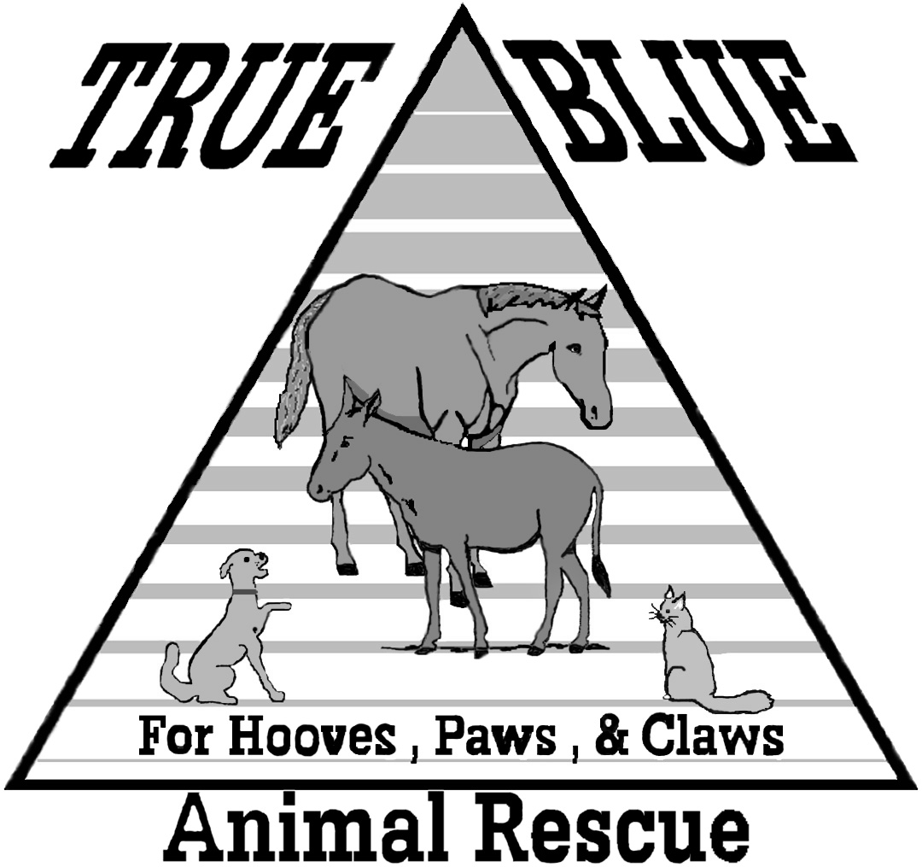 | Courtesy of True Blue Animal Rescue  P.O. Box 1107, Brenham, Texas 77834  936-878-2349  Email: help@t-bar.org  Website: www.t-bar.org

