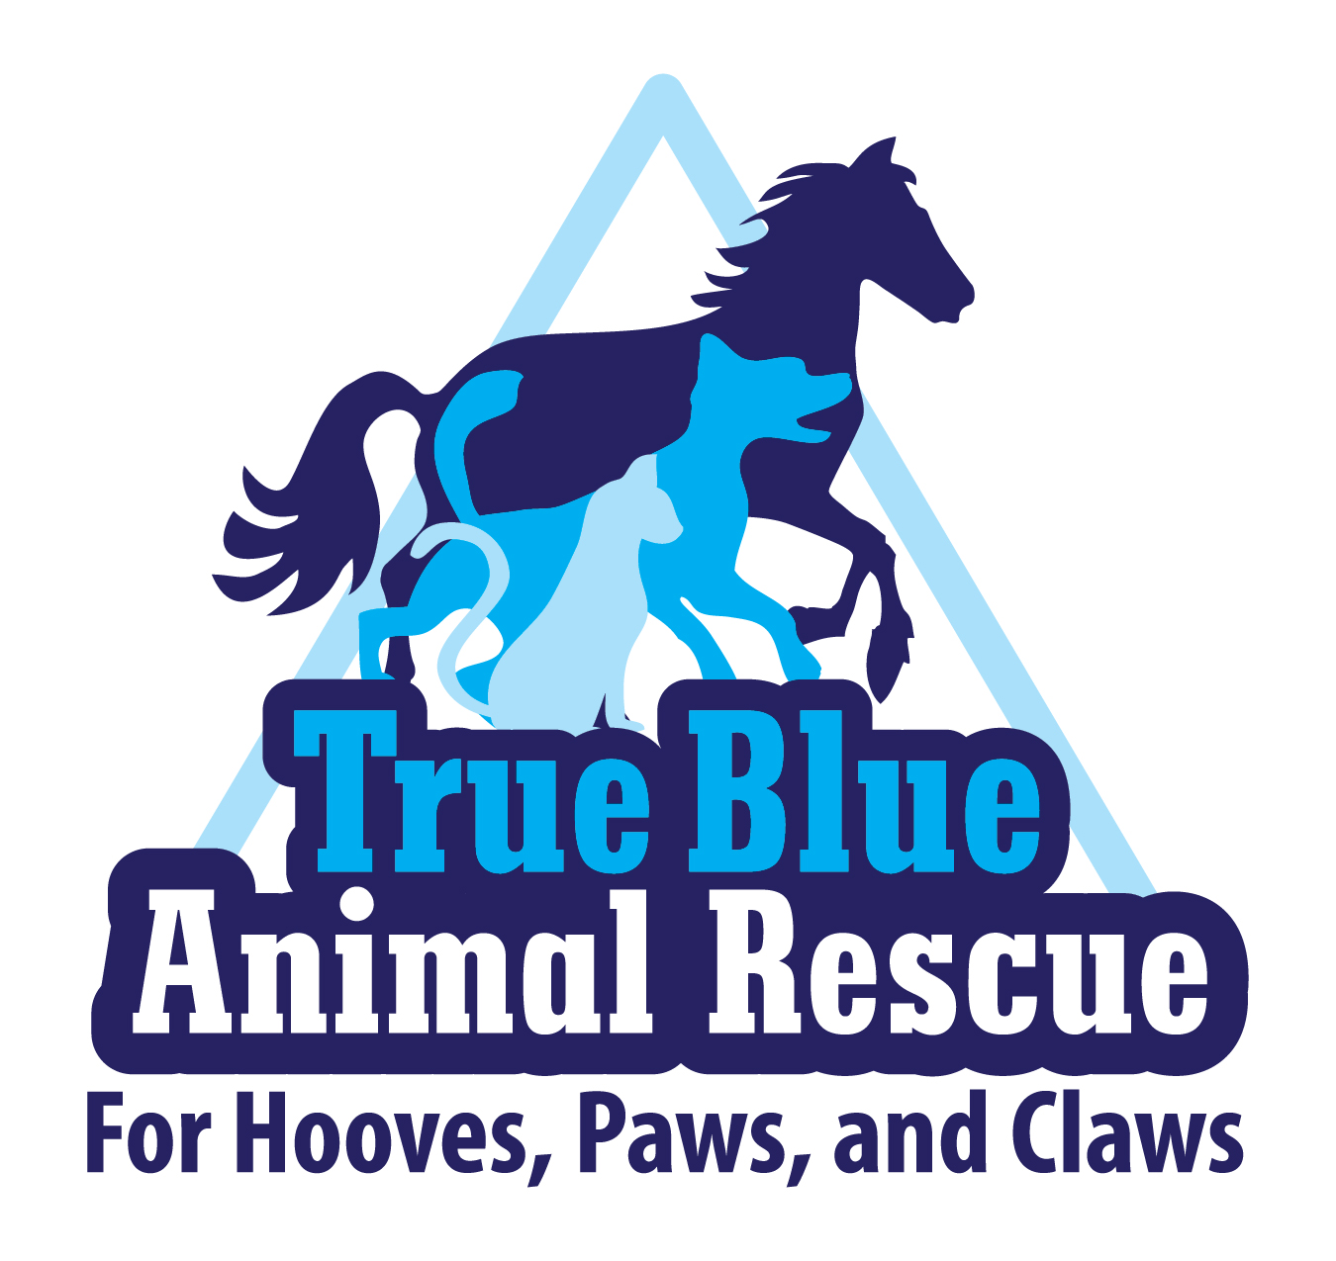
True Blue Animal Rescue (TBAR)

P.O. Box 1107

Brenham, Texas 77834
(936) 878-2349
www.t-bar.org

Volunteer Application Form

TRUE BLUE ANIMAL RESCUE (T-BAR) is a non-profit organization dedicated to helping all animals in need. T-BAR was created in an effort to educate people about caring for animals and to provide alternative care for animals when their owners are no longer able to support them. We are an organization that recognizes and respects differences. We keep the interests of the animals that we serve our number one priority. We are an inclusive group that strives to be open, honest and upholds the highest standards of integrity.

If you would like to become a volunteer, please complete this Volunteer Application and email it to Volunteers@T-bar.org.

PERSONAL INFORMATION:

Name:

Address:

City, State and Zip Code:

Home Phone Number:

Mobile Phone Number:

Email Address:

Do you have any animals? □ Yes □ No

Please give a brief description:

Please select the volunteer opportunities you are interested in:
□ Events (Fundraisers, Adoption Days, Horse Days, etc.)
□ Foster Home (Circle all that apply: dog, cat, horse) (Transport for vaccinations, treatment, adoption days)
□ Adoption Coordination (Matching fostered animals with adoptive families)
□ Education & Outreach (Kid Camps, Networking, Investigation, Outreach)
□ Animal Care & Transportation (To/From vet appointments, events, adoptive homes)
□ Marketing (Website/Social Media, Press Releases, Marketing Plans, Physical Media, etc.)
□ Fundraising & Donations (Increase donor base, Collect donated items, Fundraising events, etc.)
□ Administrative (Record keeping, Database maintenance, etc.)

Have you previously participated in animal rescues? □ Yes □ No
Have you ever been a member of any other rescue organization? □ Yes □ No

Please give a brief description:

As a volunteer for True Blue Animal Rescue, you agree to the following guidelines:
• Protect and preserve the emotional and physical well being of the animals served in TBAR.
• Maintain the highest professional standards while participating in TBAR-related activities, chat groups or e-mails, etc.
• Act with honesty and with integrity while representing TBAR.
• Follow all rules and guidelines of the TBAR organization.
• If there is a concern or suggestion that you are unable to resolve diplomatically on your own, you will contact an officer to act as a mediator.

The following is a warning that is posted by any organization that works with equines per Texas law:
Under Texas Law (Chapter 87, Civil Practice and Remedies Code), an Equine professional is not liable for an injury to or the death of a participant in equine activities resulting from the inherent risks of equine activities.

________________________________________________ _____________________________________________
Signature Date

True Blue Animal Rescue P.O. Box 1107 Brenham, Texas 77834 936.878.2349 www.t-bar.org

